**Progressive Web App (version 1.0)**

***Introduction***

* Twitter, Google, Starbucks and aliexpress, these big big company are using the progressive web apps to boost their online Presence
* PWA is a web application that captures the benefits of the native app (like android and ios app) and web application
* Printerest App is one the most famous website that usages the PWA in their website
* Progressive web applications are gaining momentum. They are noted for responsiveness, fast loading, and rapid installation. These qualities give them enough potential to replace native apps. Some experts even consider PWAs the future of the web
* A Progressive Web App (PWA) is a combination of web and native applications providing such features as push notifications, offline working, installing on the homescreen, etc.
* PWA is a technology that adds mobile app functionality to ordinary website
* The progressive web apps concept was firstly introduced by Google in 2015 when they came up with an idea to create a technology *that closes the gap between web and native apps*. Since then, the popularity
* A user visits a website and receives Web App Install Prompt ‘Add to Home Screen' which automatically installs the PWA icon to their device in case a user accepts it.
* PWA runs only in the browsers while the native app runs in the android or ios platform
* Simply a PWA is a website with all the benefits of an native app(here native refer to android and ios).   
  PWAs give you a faster, more reliable, and more engaging version of your website or eCommerce store.   
  PWAs can do most things that native apps can do, such as operate offline, access your camera and microphone if necessary, GPS, and more.  
    
  **Benefits of PWA**
* PWA supports functionality that is not available for regular website it includes offline work, push notifications , access to the geolocation and camera and microphone etc…. and maintenance is also much easier with PWA
* Instant Loading time : its load speedly as compare to normal website
* Offline browsing
* Push notifications
* Lightweight
* Low development cost
* Rapid installation
* Push notification
* Low memory size
* 60% of Flipkart's "PWA visitors had previously removed the native app to clear their device's memory and save space and installed the PWA of flipkart
* Low memory size
* PWA are in high speed and cache and display images, text and other content effieciently
* Offline mode is another strong benefit of PWA technology. Thanks to built-in service workers, the important features and information of a progressive web app are cached automatically. It means that there is no need to download it. Also, users can access the required data even when they are not connected to the Internet. The offline functionality, will be a great bonus for people living in rural communities with unstable Internet connection "or_consumers going in and out of connectivity during the day.
* just by designing the pwa we can use that app for android and apple platform becoz pwa are independents of the platform , their work on broswers
* Home screen save
* Platform independent it means pwa can run any android and ios platform without any trouble
* No updates requires like verison 1.0, 2.0 or 3.0 just design the website then publish
* Performance of our website increase
* Compatibility with Browsers
* Starbucks and Tinder these are the most top website which implement the React Progreesive web application that is powerfull and responsive
* With the help of pwa we can all accessible the features in offline works (which we get in online mode)  
  that why many companies likes Starbucks users switched from its mobile app to the PWA and the Starbucks company got their indexiability improved and improved SEO and allowed mobile user to find the starbucks in top results when user search for coffee near me Increased conversion rates Increased user time on your site, Improved user experience Increased organic search traffic,   
  PWAs are usually more affordable to cream and maintain than native apps.  
  Your most loyal customers can save your app on their home screen.  
  All of the above results in overall higher levels of performance and customer engagement, which leads to increased revenue   
  As a user:   
  PWAs are faster, loading in an instant   
  You can browse the website while being offline   
  • Better, smoother experience v   
  • PWAs use less data
* Most of the browser will automatically suggest yours vistors to install your app
* Improved conversions;
* Increased page loading speed for mobile web pages;
* Relatively low development costs;
* Enhanced user engagement;
* Higher ad clickthrough rates;
* Lessened bounce rates.
* The most popular myth states that "Google prioritizes PWA pages in their search results.” These is a wrong statement having the PWA wont help your seo but having a well executed pwa mostly likely well
* Another myth states that PWAs can't be indexed by the search engines at all. This is not true, obviously. Progressive Web Apps can be indexed just like any other web page, although the techniques used to ensure that the search engines see and understand your website's content will be different.  
    
  **How To Implement it**
* Web technologies that fuel the Progressives web apps  
  1. service workers  
  2. Web manifests  
  3. Application shell  
  4.https  
  in these pwa document we are going the cover just service workers and web manifest these are the building blocks of the pwa , if u want to study or know more about Application shell and https u can google it
* Service workers  
  1. the service workers is the an intermediary between your browsers and the network  
    
  2. With service workers, a PWA can cache and use the cached files to users when there is no internet or in offliine  
    
  3. Service work is a just a javascript code which programmer will write manually and its allow all functionality like push notification and cached and etc…..  
    
  4. And it’s a intermediate between the browser and server for example : when the user is in offline then service work will send the file from the cachae other the server  
  when user is online then servie work will serve the file from the browser-based
* Manifest file  
  1. Manifest is a json file that defines the interface of the PWA and its determines the way how pwa should be downloaded and shown to the users just like native applications from app store  
    
  2. The manifests files includes the app name and description and styling and list of the needed resources how these pwa should be look to users  
    
  3.allows the installing a PWA as a separate application to our homescreen
* Npx create-react-app myapp –template cra-template-pwa  
  here the –template cra-template-pwa  
   will added to create an app with service workers added in our create react app project ( these –template cra-template-pwa is not mandatory , if u want more comfort/safety u can use it, in our user app we have not used it)
* In index.js , we can see that the serviceWorker is not registered yet. You have to change the unregister() call to register(). So, the question of how to create a PWA with service worker using React is solved.  
  
* And finally, to make your web manifest file work, you need to add it to the pages of your web app, like in the example  
    
  <link rel=”manifest” href=”/manifest.json” />  
    
  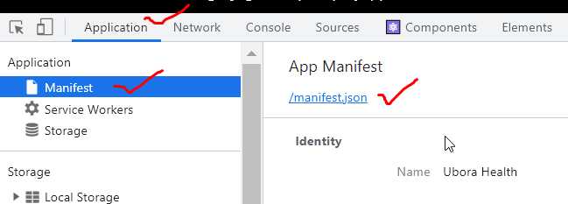
* Now we can test our app in the light house   
  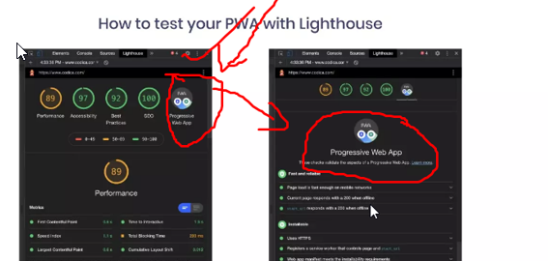

**Which Companies Got benefits**

* Tinder  
    
   1. Tinder progressive web app built with React and Redux allowed Tinder to   
  achieve such great results:  
    
   2. Loading time was reduced by 60%.   
   3. PWA is 90% lighter than the native app.   
    
   4. Users swipe, message, and edit profiles more using Tinder Online than the native app.   
    
  5. Longer sessions compared to the native app.
* Twitter : Reduced data consumption by 74%
* Alibaba : Increased conversions by 70%
* Aliexpress : Increased time spent by 76%
* The Washington Post Improved performance by 88%
* OLX Increased engagement by 250%
* Flipkart Increased reengagement rates by 40%
* Best Western River North Hotel Increased revenue by more leads 300%
* Forbes company  
  Scroll depth increase by 3x   
    
  • Sessions per user increase by 43%   
    
  • 6x increase in readers completing   
  articles   
    
  • 2x increase in engagement rate
* ALibaba  
  • % higher conversions across browsers   
    
  • 14% more monthly active users on iOS; 30% on Android   
    
  • 4X higher interaction rate from Add to Home Screen
* Flipkart  
  • Users' time on the site with Flipkart lite vs. previous mobile experience, in which user spended much of time in PWA of the flipkart lite  
     
  • 3x more time spent on site   
    
  • 40% higher re-engagement rate   
  • 70% greater conversion rate among those arriving via Add to Homescreen   
    
  • 3x lower data usage

**Converting Ordinary website app to native with 3rd partly App**

* NOTE : these documents is not about the convertion of the ordinary website to native app , its all about PWA , here im giving u a small introduction, what is what if u want know more about these one Google it
* Using a TWA (Android only)   
  In early 2019, Google implemented a new feature in Android called 'Trusted Web Activities'. This feature allows a developer to run/convert any kind of web-based application - including a PWA – within an Android app.

It's only Android, for one. Unlike Google, Apple does not offer any direct method for putting up a PWA on its store, so the TWA method is useless for it.

* Convert your PWA to Mobile Apps with MobiLoud Canvas (google it about MobiLoud Canvas if u want to know more about it )